# Introduction

It is an introduction to Git that is currently the most widely used version control system in the world, mostly thanks to GitHub. It’s also the most misunderstood version control system in the world.

Everybody understands adding, committing, pushing and pulling; but this is about as far as Git’s simplicity goes. Past this point, Git is shrouded by fear, uncertainty and doubt. Once you start talking about branching, merging, rebasing, multiple remotes, remote-tracking branches, detached HEAD states… Git becomes less of an easily-understood tool and more of a feared deity.

Complex systems like Git become much easier to understand once you figure out how they really work. The goal of this guide is to shed some light on how Git works under the hood.

Git is an open source distributed version control system created in 2005 to manage the entire Linux kernel. Instead storing file information in a central repository, Git gives every developer a full copy of the repository

It took me a pretty long time to really get Git. As I’ve continued to use Git more and more where I work, I’ve found myself trying to teach people what it is and why we use it over and over again, and the reality is that Git generally has a pretty steep learning curve compared to many other systems. I’ve seen case after case of devel­opers who love Git after they finally understand it, but getting to that point is often somewhat painstaking.

This book is aimed at the developer who does not particularly like Subversion, Perforce or whatever SCM system they are currently using, has heard good things about Git, but doesn’t know where to start or why it’s so wonderful. It is meant to explain Git as simply as possible in a clean, concise, easily readable volume. My goal is to help you understand Git internals as well as usage at a fundamental level by the time you finish this book.

To accomplish this, I’m starting the book out (after the introduction) with a section about what Git actually **does**, rather than how to use it. I found that I didn’t really understand Git and had many problems using it until I understood what it was actually doing at a low level, rather than thinking of it as a different, weird SVN-like system.

## History of Revision Control

A version control system is a software designed to keep track of the changes made to files over time. There are a number of benefits to using VCS including the following:

* The ability to undo changes. You can recover an earlier version of you work
* A complete history of all the changes
* Documentation of why changes are made. Often it is hard to remember why a change was made
* Multiple streams of history.

Working on a team , VCS provides a number of additional benefits

* The ability to resolve conflicts
* Independent streams of history.

### Files and Folders

The simplest form of version control.

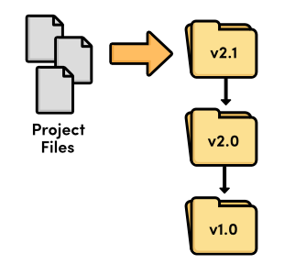

Revision control with files and folders

### Local VCS

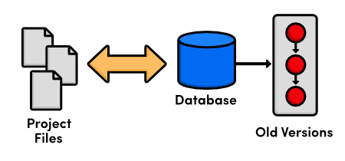

Local version control

At this point, versioning only took place on the developer’s *local* computer—there was no way to efficiently share code between several programmers

### Centralized VCS

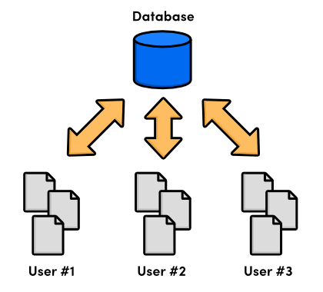

Centralized version control

### Distributed VCS

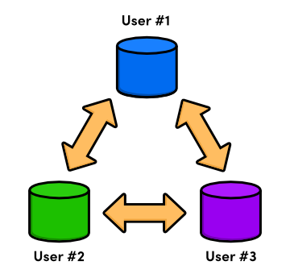

Distributed version control

- There was no longer a central repository, everyone could develop at their own pace, store the updates locally, and put off merging conflicts until their convenience.

- The local nature of DVCSs also made development much faster, since you no longer had to perform actions over a network. And, since each user had a complete copy of the project, the risk of a server crash, a corrupted repository, or any other type of data loss was much lower than that of their CVCS predecessors.

## The Birth of Git

As a source code manager for the entire Linux kernel, Git had several unique constraints, including:

* Reliability
* Efficient management of large projects
* Support for distributed development
* Support for non-linear development

### More specifically, Git is a distributed version control system which means that everyone working with a project, not just the current state of the files.

### Github is platform where you can upload a copy of your Git repository. But more than than a centralized location to share your repository, it allows you to collaborate much more easily with other people on your projects. It does that by providing a web interface to manage it

Though originally used for just the Linux kernel, the Git project spread rapidly, and quickly became used to manage a number of other Linux projects,

## Installation On Windows

For Windows users, Git installation will install a special command shell called *Git Bash*. To test your installation, open a new command prompt and run

$ git --version.

Simply download the exe file from the “downloads list”:http://code.google.com/p/msysgit/downloads/list, execute it and follow the on-screen instructions.